BTEC Sport Unit 1A: Skeletal System

Bridging Materials

1.

3.

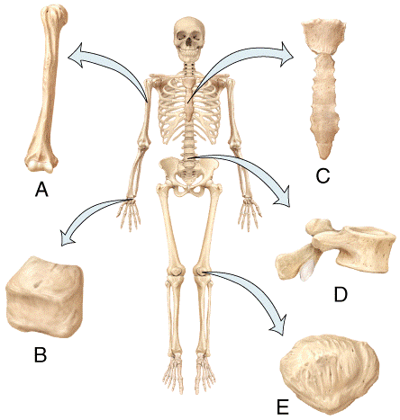

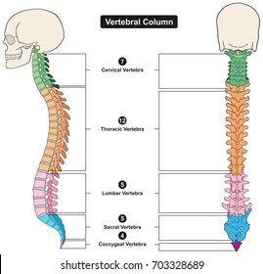1.

**Watch the YouTube video below and answer the questions:**

[Anatomy & Physiology types of bones BTEC SPORT LEVEL 3 Unit 1 - YouTube](https://www.youtube.com/watch?v=B2Uxq_C14d4)

**Types of Bone**

1. Label the diagram showing the 5 different types of bones.

2. Describe the function of each type of bone within the diagram and give at least one example of each bone.

3. Label the spinal diagram.

**Process of Bone Growth**

1. What is the process of bone growth called?

____________________

1. Which 2 minerals are included in the process and accumulate on the cartilage?

__________________ & __________________

1. Where is the epiphyseal plate located and what occurs there?

_______________________________________________________________________________________________________________________________________

1. When is the epiphyseal line formed?

__________________________________________________________________________________________

1. Where is the epiphyseal line formed?

_____________________________________________

1. What is the difference between osteoblast and osteoclast cells?

_______________________________________________________________________________________________________________________________________

|  |  |  |
| --- | --- | --- |
| **Type of Bone** | **Function** | **Examples** |
|  |  |  |
|  |  |  |
|  |  |  |
|  |  |  |
|  |  |  |

2.

**Further Reading**

[11.5 Bone Growth, Remodeling, and Repair – Human Biology (tru.ca)](https://humanbiology.pressbooks.tru.ca/chapter/13-5-bone-growth-remodeling-and-repair/)